**CP Club 365 Days Challenge**

**Programming language – C++**

**Problem Statement**

<https://www.codechef.com/problems/MATCHES>

Git :- <https://github.com/Vedantbharad2603/CP_club_365_Days>

**Your Code**:

// 0x121Day of 0x365Days challenge

// VEDANT BHARAD

// 15-2-2023

#include <iostream>

using namespace std;

int main() {

    // your code goes here

    int t;

    cin>>t;

    while(t--){

        int a,b;

        cin>>a>>b;

        int sum = a+b;

        int required[10] = {6,2,5,5,4,5,6,3,7,6};

        int con = 0;

        while(sum!=0){

            int temp = sum%10;

            con += required[temp];

            sum /= 10;

        }

        cout<<con<<endl;

    }

    return 0;

}

**Output (Screen Shot)**:

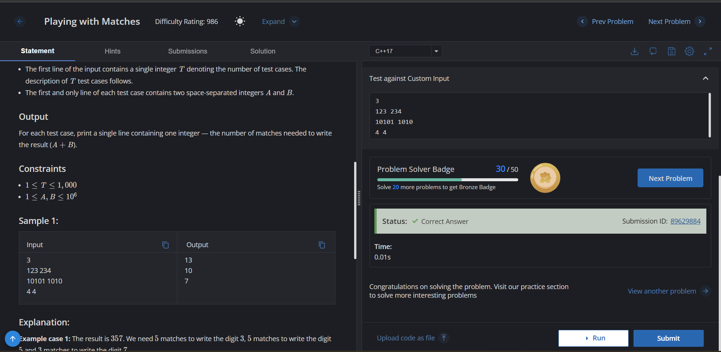

**Understanding about problem:**

* In this task I need to return number of matches required to write the sum of A and B.

Note: If you can't understand the problem, feel free to contact us and we'll help you. Please don't copy and paste from anywhere.

ALL THE BEST

Team CP Club